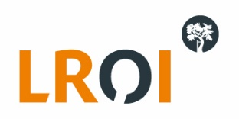
Expression of Interest Form LROI research
Application to use data from the Dutch Arthroplasty Register (Landelijke Registratie Orthopedische Interventies LROI) for research purposes
Study title

General information chief investigator
Title
Initials
Name
Position
Institute/organisation
Contact address
Contact email
Contact telephone

Other project members involved in the data handling
1. | Name  Position  Institute
2. | Name  Position  Institute
3. | Name  Position  Institute
4. | Name  Position  Institute
5. | Name  Position  Institute

Research:
1. Research question (maximum 100 words)
2. Summary (maximum 250 words)
3. Outcome measure(s) (maximum 50 words) including expected data availability in the LROI
4. Proposed time frame (e.g. start data, duration)
5. Final product

Data is provided on the level of detail needed to answer the research question. Data will not contain any patient identifiable data and is made untraceable to physician(s) and hospital(s). Traceability of data on the level of the physician or hospital will only be performed after approval of the concerning hospital(s) or physician(s).
Please send this Expression of Interest form to lroi@orthopeden.org.

